*Florida International University*

*School of Computing and Information Sciences*

Software Engineering Focus

Feature Document

User Story ID #1011

**Name: Accept Invitation**

**Team Member: Alvaro Silva**

**Project: SkillCourt 7.0**

**Product Owner(s)**: Guðmundur Traustason

**Mentor(s)**: Masoud Sadjadi

**Instructor**: Dr. Masoud Sadjadi

**Accept Invitation:**

* Description: **As a** User **I would like** to accept invitations **so that** I can play against the player who invited me to play against him.

Acceptance Criteria

* User has an account with SkillCourt
* User is logged in his account
* User was invited by other user

**Use Case**

* Name: Accept Invitation
* Actor: Player
* Preconditions: Player opened the notification ***and***

System displayed the correct UI

* Description <Flow of events>:

|  |  |
| --- | --- |
| Actor Steps | System Steps |
| 1. Actor clicks the Accept button |  |
|  | 2. System add user to the room |
|  | 3. System shows the UI of the room |

**Use Case Diagram**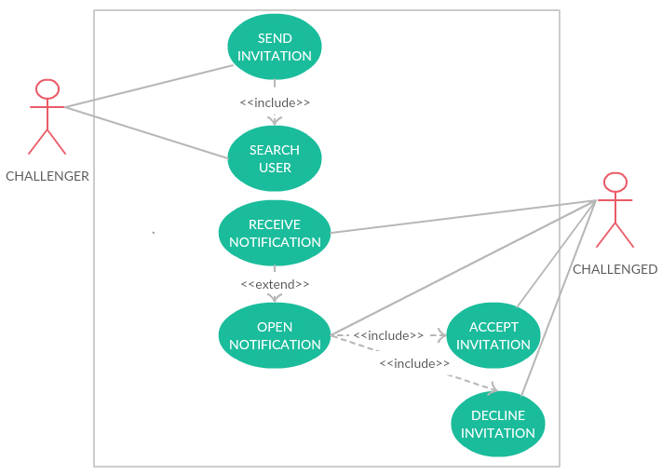

**Sequence Diagram**

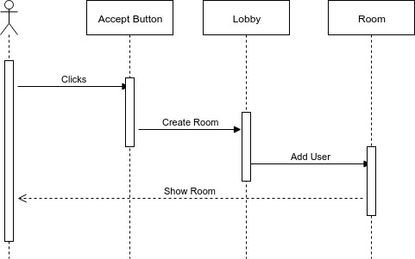

**Unit Test**

* Test case ID:
* Description/Summary of Test: Test if the implementation for accepting the invitation works
* Pre-condition: SkillCourt app running.
* Expected Results: System adds the user to the room.
* Actual Result: System does not add the user to the room and create a new one.
* Status (Fail/Pass): Fail.

**Visual User Guide**

